 **The Ark Newsletter**

**February 2022**

**Staff**

Our new administrator, Tracey Carter, commenced her employment with us on 4th January and is currently learning the roles and responsibilities.

Sadly, Nanny Jane left the Baby Room at the beginning of January. Lucy has joined the Baby Room team and is currently working all day on a Wednesday and Thursday, and on a Friday afternoon.

Jody has decided not to return to work following her maternity leave, consequently Emma has accepted the position of Baby Room Leader on a permanent basis.

**Children’s Activities**

The children have been using our designated baby garden to continue to explore and develop their physical skills. Since the weather has been a lot chillier lately, they have wrapped up extra warm to explore and experience the different weathers such as cold, windy, and sometimes a little bit wet!

Our youngest children thoroughly enjoyed all the different activities provided during Chinese New Year; they had the opportunity to explore noodles, paint their own Chinese lanterns and enjoy tasty Chinese food for snack.

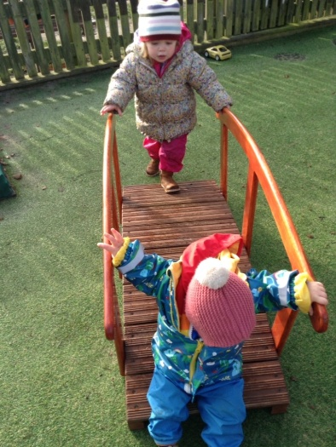 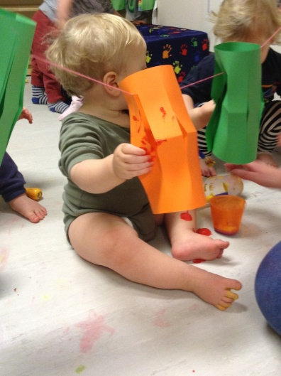 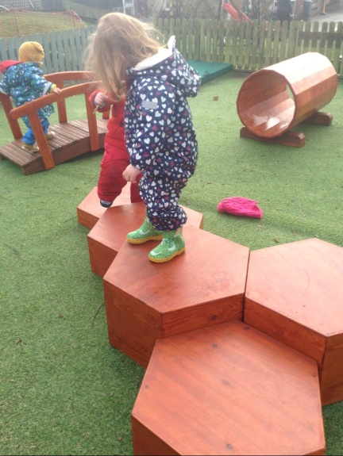

Toddler Room children have been continuing to explore emotions and talking about how we feel when we are happy, sad and excited, and have also been creative with counting and construction. They have also been taking part in activities to develop fine motor skills and their hand-eye coordination, such as puzzles and peg boards

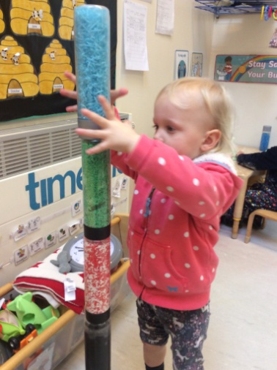 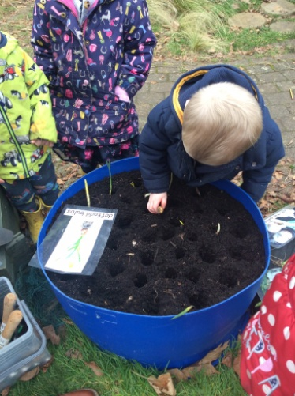 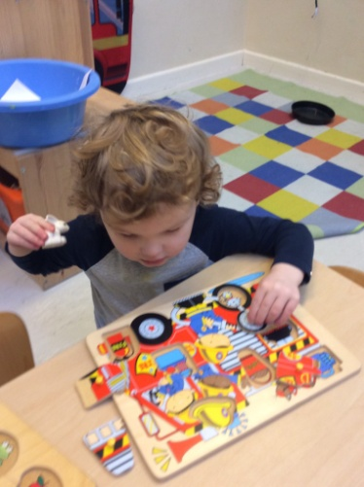

As the Pre-school room is about enabling children to become independent and confident, the children are really enjoying tasks such as chopping up their own snack and serving themselves lunch. They are clearly very keen to gain more independence. During circle times they discuss the days of the week and the weather and how we are feeling. The children are becoming more comfortable with taking turns and sharing their personal experiences and feelings during these times. The children have been learning about dangers and risk-taking. They have been given the opportunity to use resources that teach them how to safely handle tools and resources that could be dangerous if not used properly. The children thrive with this sense of responsibility and are able to give the activity the high level of concentration it requires. These activities include using scissors or the hammer and nail set. When used safely these activities are excellent for their fine motor skills

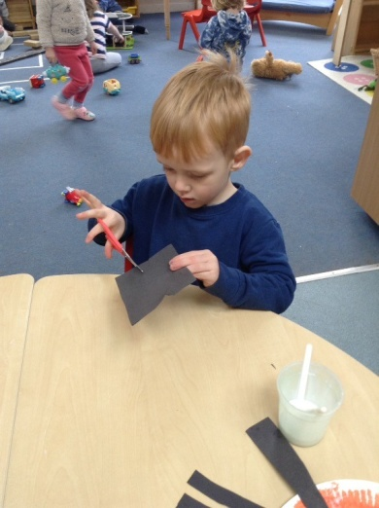 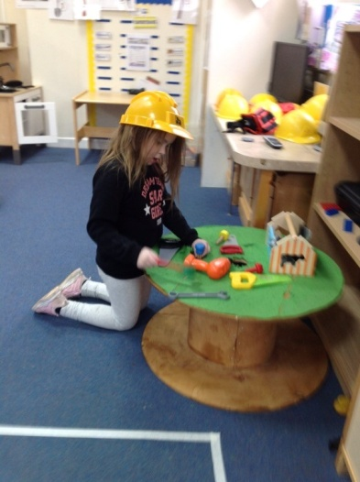 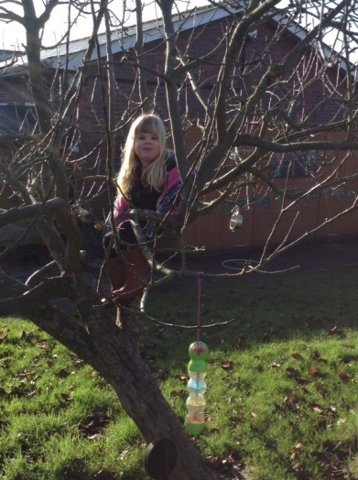

**A polite reminder**

Please ensure that your child comes to nursery in clothing appropriate for the weather. We spend time outside as much as possible during the day and children need to be warm and dry. Please ensure your child has enough layers on to keep them warm under their coat and that they have suitable and safe footwear on. Please make sure all your child’s belongings are clearly named.

This term we have been opening The Ark and Raft buildings to parents who are now able to bring their children in to their respective rooms at drop off times and hand over to their child’s key worker. We do ask parents to wear face coverings when entering either building. At collection times children will be taken out to their parents, and although we have said that face coverings are no longer essential at pick-up time, we do feel it would be wise, especially for parents of babies and toddlers, to continue wearing face coverings at this time as it is difficult to maintain social distancing when handing over.

**Date for your diary**

The Ark will be hosting an Easter Bingo on Friday 1st April 2022 at Child Okeford Village Hall. Doors open 7pm eyes down at 7.30pm

We would be most grateful if parents could support The Ark in both attending the bingo (especially as it’s a fun evening!) and donating any suitable prizes. Thank you.

**Spring Term 2022**

Tuesday 4th January – Friday 8th April

**Holiday Club/Inset day Friday 18th February.**

Half-term and Holiday Club Monday 21st – Friday 25th February inclusive

Easter and Holiday Club Monday 11th- Friday 22nd April inclusive.

**Bank Holidays Good Friday 15th April and Easter Monday 18th April when The Ark will be closed**

**Summer Term 2022**

Monday 25th April – Friday 22nd July

Half-term and Holiday Club Monday 30th May – Tuesday 7th June

**Bank Holidays Thursday 2nd June and Friday 3rd June when The Ark will be closed**

**Holiday Club/Inset day Monday 6th June.**

Summer and Holiday Club Monday 25th July – Friday 26th August inclusive

**The Ark Closure week Monday 29th August – Friday 2nd September**

Sarah McNab

Nursery Manager